Project Design Document

1. Design Intent
The aim of this project is to create an interactive cinematic backdrop experience where users can step into a stylized scene and record themselves in an engaging, visually dynamic environment.
The experience is designed for visitors at exhibitions or events, especially those interested in interactive media and storytelling-based installations.
Instead of just a static photo booth, this system creates a triggered environment where motion, light, and sound combine to simulate a dramatic scene.

2. Inspiration & References
- Initial idea: building a full-scale photo booth room (approx. 4 × 4 × 6 feet)
- Due to complexity (space, wiring, structure), the idea evolved into a compact Dhurandhar-themed backdrop
- Concept inspiration:
- Recreating the iconic “Aari Aari” scene from the second movie
- Adding a handheld prop for users to interact with while recording

3. User Journey
- The user approaches the setup
- The user selects a color scheme on the website (via laptop)
- The LED system updates to reflect the selected theme
- The user picks up the prop and positions themselves in front of the booth
- The operator presses the pushbutton to start the experience
- The DC motor begins rotating the reflective setup
- The user presses the limit switch on the prop, triggering a buzzer sound effect
- Light reflects dynamically, creating a cinematic environment
- After 10 seconds, the motor stops automatically
- The LEDs and prop remain functional throughout

4. Success Criteria
Functional:
- Pushbutton successfully starts motor rotation
- LEDs turn on and change based on website input
- Motor runs smoothly and stops automatically after 10 seconds
- Buzzer triggers reliably via limit switch
User Experience:
- Immediate visual feedback after selecting color
- Smooth, immersive lighting and motion
Reliability:
- Website, LEDs, and prop work continuously even during motor operation
- Stable wiring and connections
- No lag or system crashes

5. System Overview
The system is a microcontroller-based interactive setup combining input controls, lighting, sound, and motion.

Working Explanation:
- The ESP32 acts as the central controller
- A laptop interface (website) allows users to select LED color schemes
- Two Neo Pixel rings generate dynamic lighting effects
- A pushbutton triggers the motor sequence
- A DC motor + driver rotates reflective elements to scatter light
- A limit switch embedded in the prop activates a buzzer sound
- A power distribution system (adapter + module + jack connections) ensures stable operation

6. High-Level Block Diagram
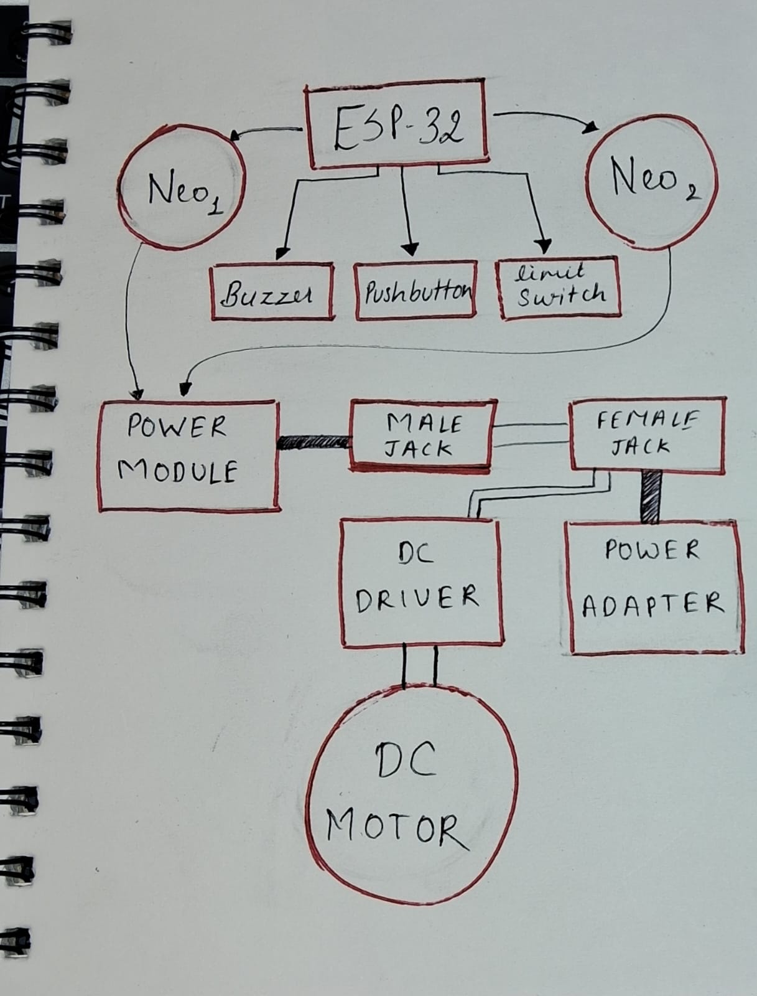

7. Input / Output Mapping
Input | Process | Output
Pushbutton ( | ESP32 detects LOW signal → motor_start() → sets timer using ticks_ms() | DC motor starts rotating for 10 seconds
Timer (internal) | motor_tick() checks time → stops motor after duration | Motor stops automatically
Limit Switch | limitswitch_tick() detects press → calls buzzer_start() | Buzzer plays “pew pew” sound pattern
Website Theme Selection | HTTP request /theme/<name> received → update_rings() called | NeoPixel rings change color
Continuous Loop | Runs motor_tick(), buzzer_tick(), limitswitch_tick() repeatedly | Smooth simultaneous functioning of all components
Browser Request | stream_page() sends HTML page | Web interface displayed on user device
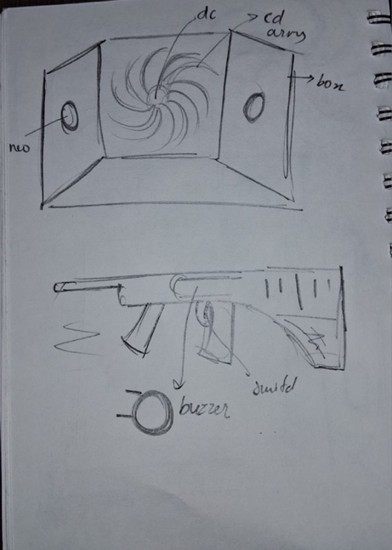
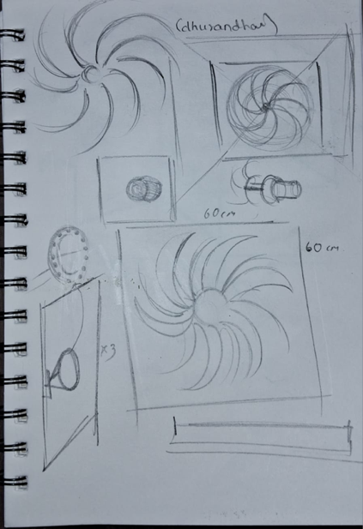

8. Sketches & Concepts

9. Final System Architecture (Labelled)
